|  |  |  |  |  |  |
| --- | --- | --- | --- | --- | --- |
| Name |  | Date |  | Teacher |  |

## Assessment type: Task 12 Sci Inq 4 Part 2 Total 25M

### Task: Matching profiles – DNA sequencing (fingerprinting)

You will examine a technique used to identify the original source (carcase) of a contaminated meat sample.

At the end of this document you will find:

* four meat samples (DNA sequences)
* one restriction enzyme template.

### Recombinant DNA technology: Matching profiles

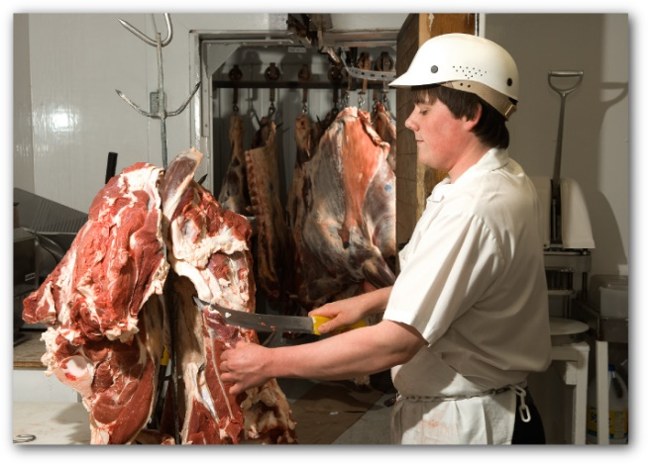Use the information given and your own research from other resources, such as the internet and textbooks to examine a technique used to identify the original source (carcase) of a contaminated meat sample.

A butcher has been told that some of the meat in his shop has been contaminated with the pesticide DDT. He needs to track down the source and inform his supplier that the meat is not suitable for human consumption. Recombinant DNA technology can be used to identify the original source. You are the scientist who has been given the task to identify the source.

During extensive investigations the origin of the contaminated meat sample was narrowed down to three carcases. Meat samples were taken from the three carcases and carefully labelled as meat sample 1, 2 and 3. The source of the contaminated meat sample can be found by separating and comparing DNA fragments of the affected meat sample with DNA fragments from the three meat samples. A restriction enzyme used to cut DNA into fragments is EcoRI.

### 

### What you need to do

1. Cut out the three meat samples and the contaminated meat sample DNA sequence from the samples provided. Glue together to form a single line for each sample.
2. Use your activated restriction enzyme to locate the restriction site(s) for the contaminated meat sample.
3. For each sample you will need to cut it at the beginning and the end using both parts of your restrictive enzyme. This will produce fragments.
4. For each sample, group identical fragments together.
5. Arrange the groups of fragments into a column from longest to shortest for each sample.
6. Compare each sample’s DNA fingerprint with the contaminated meat sample. To do this you need to compare the length and sequence in each group of fragments with the contaminated sample.
7. Answer the questions below.

### **Questions**

1. Draw a DNA fingerprint for the meat samples, including the contaminated sample; on the ‘gel’ below (remember DNA molecules are negative). (4M)

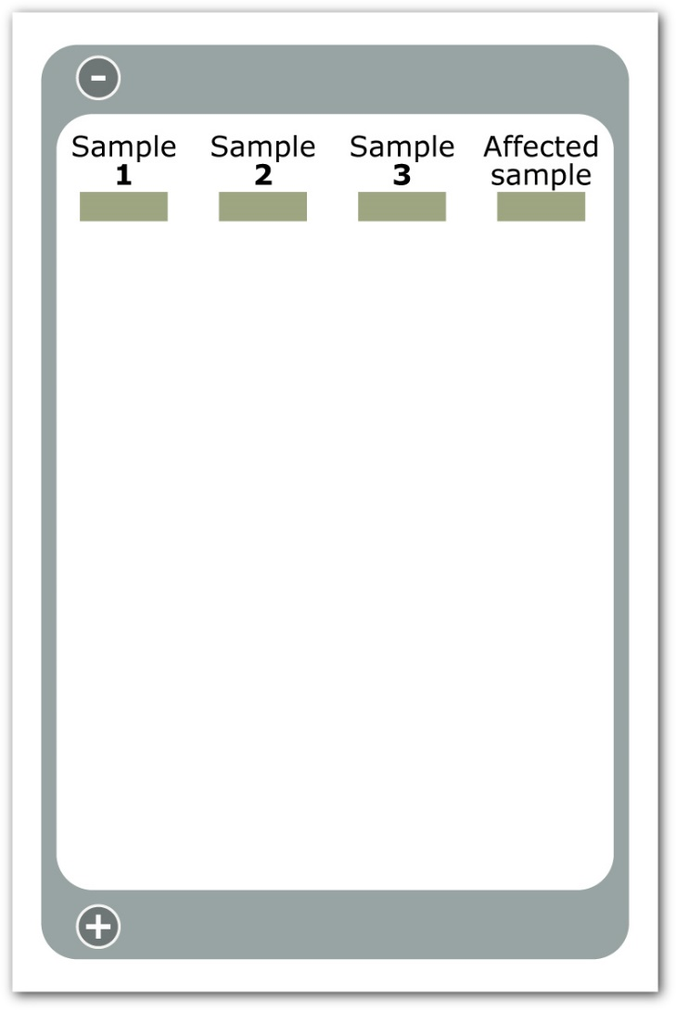

1. What conclusions can you make from comparing the DNA fragments in the above activity? (2M)

|  |
| --- |
|  |

1. Could the restriction enzyme, EcoRI, be used to cut DNA from another species? Explain your answer. (2M)

|  |
| --- |
|  |

1. Restriction enzymes are used to cut DNA into fragments. The restriction enzyme Alu1 produces blunt ends while EcoRI produces sticky ends. Explain what is meant by ‘blunt ends’ and ‘sticky ends’. (2M)

|  |
| --- |
|  |

1. If you wished to join pieces of DNA fragments, which type of enzyme would you use? (1M)

|  |
| --- |
|  |

1. Using the enzyme identified in the previous question would you expect a sample containing DNA fragments with sticky ends to join together faster than a separate sample containing DNA fragments with blunt ends? Explain your choice. Assume all other variables are kept constant. (2M)

|  |
| --- |
|  |

## Multiple copies of one long fragment of DNA where made using PCR. The copies were treated with the restriction enzyme EcoRI. A DNA profile was made using gel electrophoresis and three shorter fragments were produced as shown below.

The size of each fragment is given in kbp (kilo base pairs).

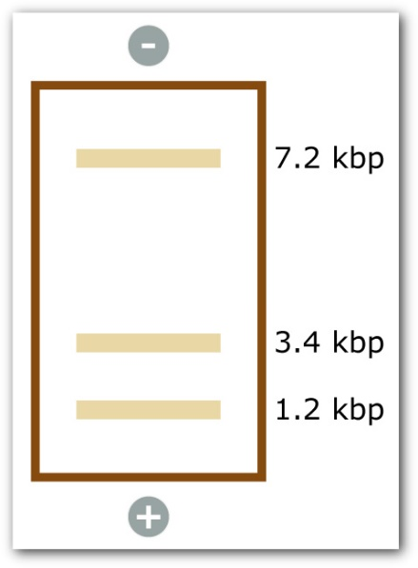

a) In which direction did the fragments travel? (1M)

|  |
| --- |
|  |

b) What size was the original fragment of DNA before being treated with EcoRI? (1M)

|  |
| --- |
|  |

c) How many recognition sites for the restriction enzyme EcoRI were present in the original fragment of DNA? (1M)

|  |
| --- |
|  |

d) A copy of the original fragment of DNA was treated with another restriction enzyme, Alu1. A DNA profile was produced using gel electrophoresis and only one DNA fragment was produced. Explain. (2M)

|  |
| --- |
|  |

8. a) Plasmids are used as vectors in the production of recombinant DNA to produce transgenic organisms.

Briefly explain the following terms: (4M)

* + 1. transgenic organism

|  |
| --- |
|  |

* + 1. plasmid

|  |
| --- |
|  |

* + 1. vector

|  |
| --- |
|  |

* + 1. recombinant DNA.

|  |
| --- |
|  |

b) Summarise the steps, including the enzymes involved, in the production of recombinant DNA. (3M)

|  |
| --- |
|  |